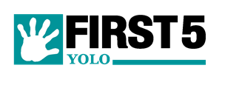

FIRST 5 YOLO
EXECUTIVE COMMITTEE MEETING

February 4, 2019, 2PM
District 4 Conference Room
Helen MacLead Thomson Building
600 A Street, Suite C
Davis, CA 95616

- Call to Order/Welcome/Public Comment

- Staff Development and Organizational Updates

- Update on First 5 Yolo Partnerships for CHILD Project, Help Me Grow, and IMPACT

- Update on FY19/20 Planning

- Adjourn

Posted in accordance with the Brown Act on January 24, 2019 before 5PM.
The Offices of First 5 Yolo Children and Families Commission, 502 Mace Blvd. Ste. 11 Davis, CA 95618
County of Yolo Administration Building, 625 Court Street, Woodland, CA 95695
County of Yolo Davis Building, 600 A Street, Davis, CA 95616

