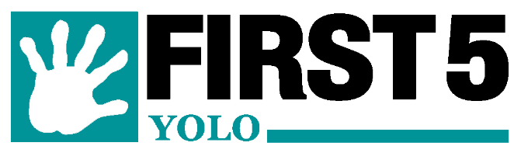

First 5 Yolo COVID-19 Emergency Relief Funding Application
Description:
First 5 Yolo has established an emergency relief funding application process for agencies serving Yolo County children 0-5, their families, and childcare providers serving essential workers in Yolo County during the COVID-19 pandemic, pursuant to Resolution No. 2020-01: COVID-19 Response, formally adopted by the First 5 Yolo Commission on April 8, 2020. First 5 Yolo will accept applications on an ongoing basis through December 31, 2020 or until allocated funds have been expended.

Intent:
The intent of emergency relief funding is to rapidly respond to the needs of children prenatal to five and their families in Yolo County during this difficult and unprecedented time, and to support childcare providers, whose ability to ensure the safety and meet the needs of children of essential workers is critical to the community’s ability to respond to the health crisis.

Eligibility:
Agencies working to support vulnerable children ages 0-5 are eligible to apply for one-time funding up to $2,500, for the purchase of items including but not limited to: essential supplies for children and families and childcare providers, and technological or other expenses related to changing services and work flows during the COVID-19 emergency.

Requested funds can only be used to support future purchases and may not be used to supplant allocated funds or recoup funds already expended prior to approval of an application. Additionally, applicants must be registered non-profits, private, or governmental agencies with a valid Tax ID who will provide a copy of their W-9 prior to receiving payment from First 5 Yolo.

Recognition:
First 5 Yolo welcomes and encourages funding recipients to share First 5 Yolo information describing First 5 Yolo funded programs and services, as well as other resources available on the First 5 Yolo website (www.first5yolo.org) and/or the First 5 California website (www.first5california.com) to further support children and families.

Application:
To apply for emergency relief funding, please complete the brief application on Page 2, in its entirety, and submit via email to cfc@first5yolo.org. First 5 Yolo may contact you to discuss your application prior to acceptance or notification of award. First 5 endeavors to respond within 1 week.

First 5 Yolo County Mission
First 5 Yolo will assist our community to raise children who are healthy and ready to learn. We will assure that our resources are effectively used and all community voices heard.

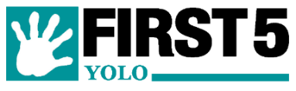
Sponsorship Application

- Date of Application: _______________________

- Contact Information
Agency (organization): ______________________________________________________________
Primary contact name for Agency: ____________________________________________________
Phone:___________________ E-mail:__________________________________________________
Address:_________________________________________________________________________
Phone:_______________________ E-mail:______________________________________________

- Type of Business: Non-Profit Private Government Other: __________________

- Amount Requested (limit of $2,500): ____________________

- Briefly (one or two sentences) describe your agency’s response to the COVID-19 Pandemic:

- Briefly describe of how requested funds will be utilized and the population to be served (note: First 5 funding can only be spent in support of children 0-5 and their families living in Yolo County):

Signature
Please sign and date the application below (electronic signature acceptable). The signing of this application indicates that you have read and agree to First 5 Yolo’s Sponsorship Guidelines.
_________________________________ _______________________
Signature Date
__________________________________
Name (printed) and Title

QUESTIONS?
Contact the First 5 Yolo office at 530-419-2475 or via e-mail: cfc@first5yolo.org

