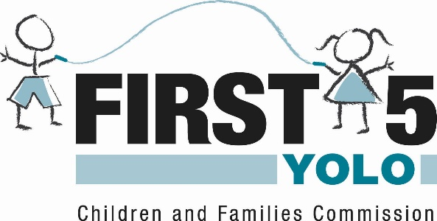

COMMISSIONERS
Francisco Castillo – District 1 Sally Brown – District 2 Jenn Rexroad – District 3
Heidy Kellison – District 4 Sue Heitman – District 5 Jesse Ortiz – YCOE
Jill Cook – Dept. County Jim Provenza, Chair - Nichole Arnold – Children
Administrator (CAO) Board of Supervisors w/ Special Needs
AGENDA

January 10, 2018
3:00-5:00 pm
First 5 Yolo
502 Mace Blvd. Ste. 15
Davis, CA 95618
ADMINISTRATIVE AGENDA
1. | Chair | Call to Order
2. | Chair | Roll Call
3. | Chair | Consider Approval of the Agenda
4. | Chair | Opportunity for Commissioners to state Conflict and Recusal
5. | Public | Public Comment
6. | Chair | Updates and Announcements from the Chair
CONSENT AGENDA
Executive Director recommends approval of Consent Agenda Items 7-10
General Administrative Function
7. | Chair | Approve First 5 Yolo Commission Meeting Minutes from 12/13/17
8. | Staff | Adopt Calendar for February and March 2018
9. | Staff | Receive Sponsorship Fund Allocations Report (FIMR-Kick Count Magnets)
10. | Staff | Approve Revised First 5 Yolo Logo to Improve Alignment with The First 5 Network
REGULAR AGENDA Presentation/Discussion/Possible Action
11. | Executive Director | Public Hearing: Receive First 5 Yolo Annual Local Evaluation Report | 45 minutes
12. | Executive Director | Adopt Local Evaluation Report | 5 minutes
13. | Executive Director | Strategic Planning Retreat Preparation | 60 minutes
14. | Executive Director | Receive Executive Director Report | 5 minutes
15. | Commissioners | Receive Reports from Commissioners | 5 minutes
16. | Chair | Adjournment
Next meeting scheduled: |  | Commission Strategic Planning Retreat  February 7, 2018 10:00AM – 3:00 PM  El Macero Country Club  44571 Clubhouse Drive El Macero, CA 95618
I declare under penalty of perjury that the foregoing agenda was posted January 4, 2018 by 5:00 PM at the following places:
- On the bulletin board at the East entrance of the Erwin Meier Administration Center, 625 Court Street, Woodland, California 95695
- On the bulletin board at the First Yolo office, 502 Mace Blvd. Ste. 11, Davis, California 95618
Lauren Adams, Management Services Officer
First 5 Yolo Children and Families Commission

If requested, this agenda can be made available in appropriate alternative formats to persons with a disability, as required by Section 202 of the Americans with Disabilities Act of 1990 and the Federal Rules and Regulations adopted in implementation thereof. Persons seeking an alternative format should contact First 5 Yolo for more information. In addition, a person with a disability who requires a modification or accommodation, including auxiliary aids or services, in order to participate in a public meeting should telephone or otherwise contact the First 5 Yolo as soon as possible and preferably at least 24 hours prior to a meeting. First 5 Yolo may be reached at telephone number 530-669-2475 or at the following address: First 5 Yolo, 502 Mace Blvd. Ste. 11, Davis, CA 95618.

